21BDS0340

Abhinav Dinesh Srivatsa

Information Security and Audit Lab

Task – II

**Question 1**

Aim: Create 2 LANs and connect them with a router

Tools and Concepts Required:

* Cisco Packet Tracer
* Switch
* Hub
* Router
* Personal Computers
* Wiring

Procedure:

* Create LAN1 using switch with 5 PC
* Create LAN2 using hub with 5 PC
* Interconnect the LAN using a router
* Understand the packet transmission across the LAN

Output:

Create LAN1 using switch with 5 PC:

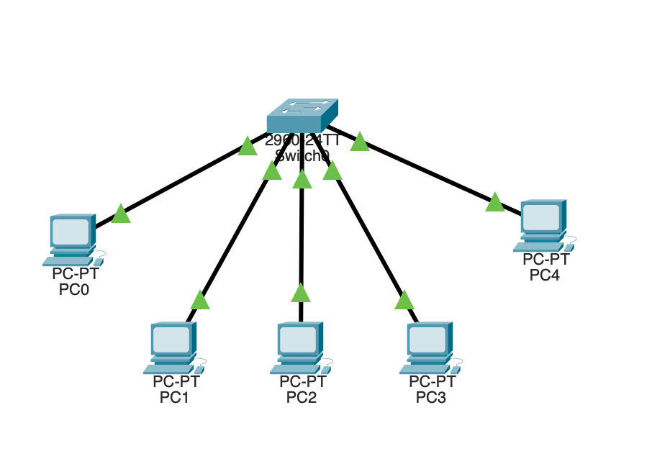

Create LAN2 using hub with 5 PC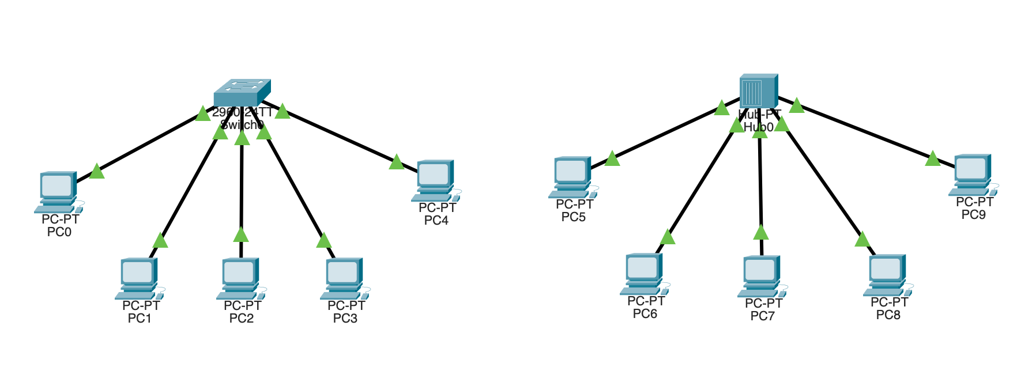

Interconnect the LAN using a router:

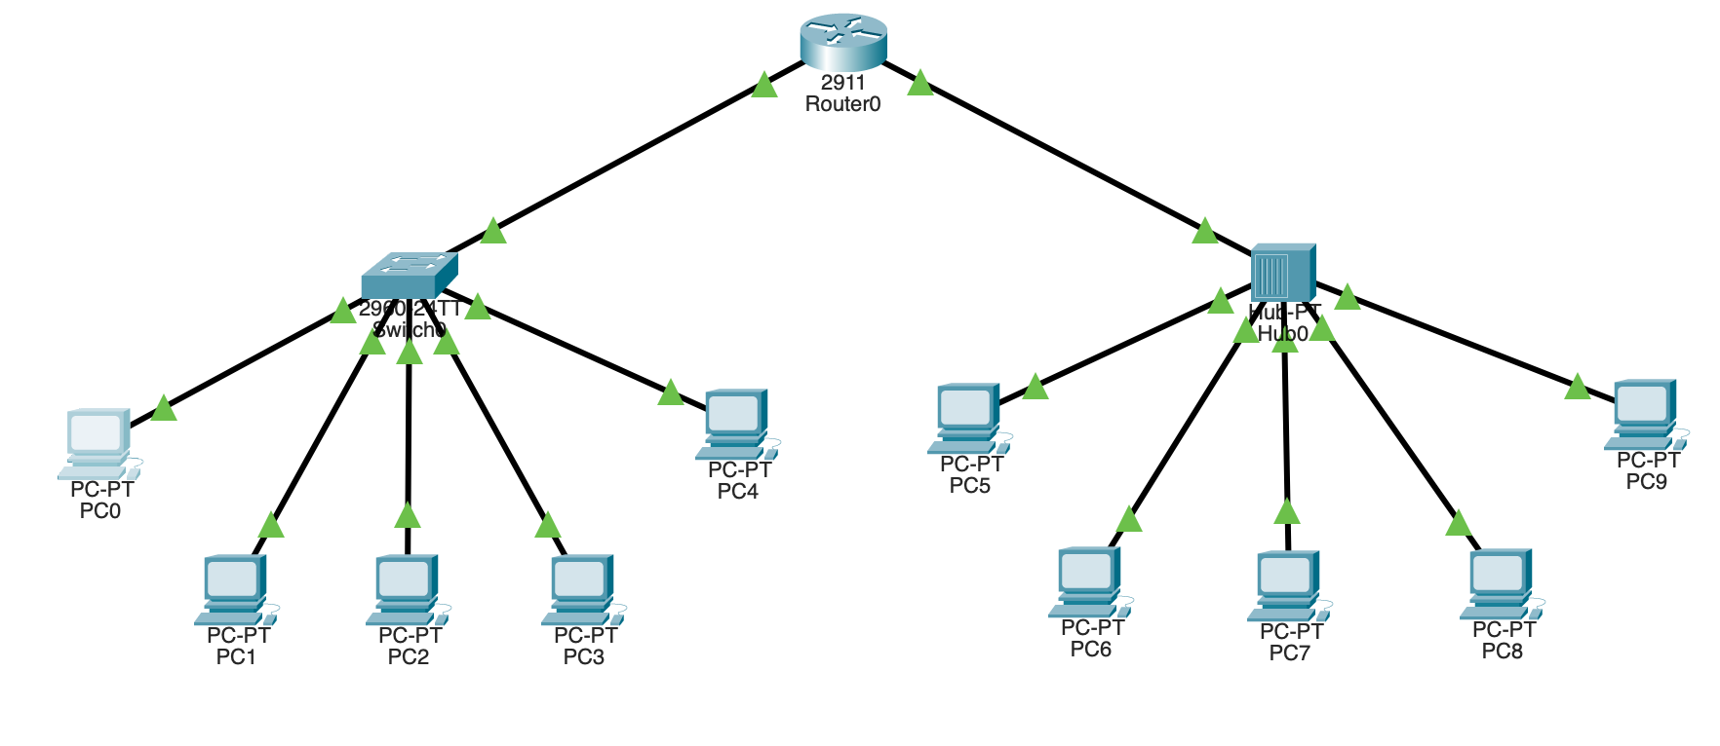

Understand the packet transmission across the LAN:

Security Analysis:

|  |  |  |
| --- | --- | --- |
| Vulnerabilities | Threats | Attack |
| Outdated software | Physical access with insider access | Malware infection to hardware by insider access |
| Weak passwords | Unauthorised access by gaining a password | Denial of service by blocking hub access |
| Lack of encryption | Data theft by insider attacks | Phishing by insider attack |
| Direct offline hub access |  |  |

Prevention:

* Keeping the nodes and hub in a sperate room for nobody to access directly.
* Encrypt and mandate strong password usage

Result:

This network is extremely secure, but all the nodes can only connect to each other and none of them to the internet. This type of connection is very good for local file storages and broadcasting. This also enables different LANs to connect with each other through the usage of a router.

**Question 2**

Aim: Create 2 LANs with routers and connect them

Tools and Concepts Required:

* Cisco Packet Tracer
* Switch
* Router
* Hub
* Personal Computers
* Wiring

Procedure:

* Create LAN1 using switch with 5 PC router R1
* Create LAN2 using hub with 5 PC router R2
* Interconnect the routers and configure the routing table
* Understand the packet transmission across the LAN

Output:

Create LAN1 using switch with 5 PC router R1:

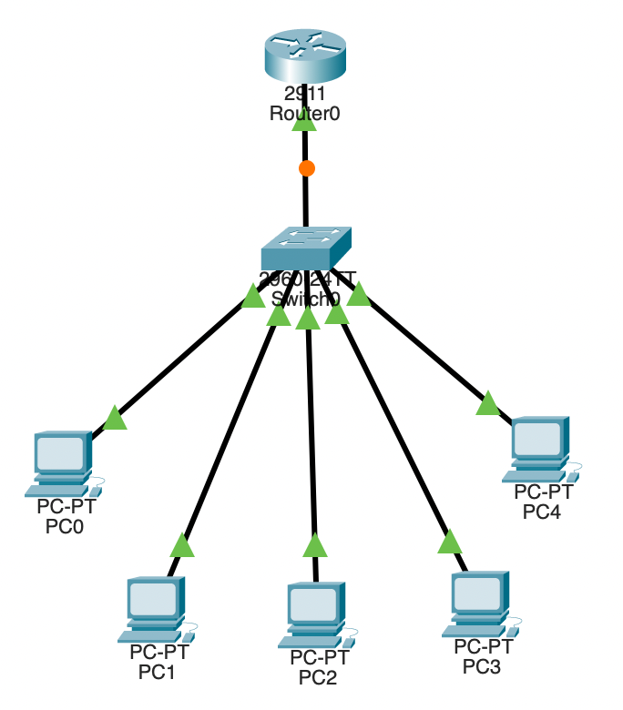

Create LAN2 using hub with 5 PC router R2:

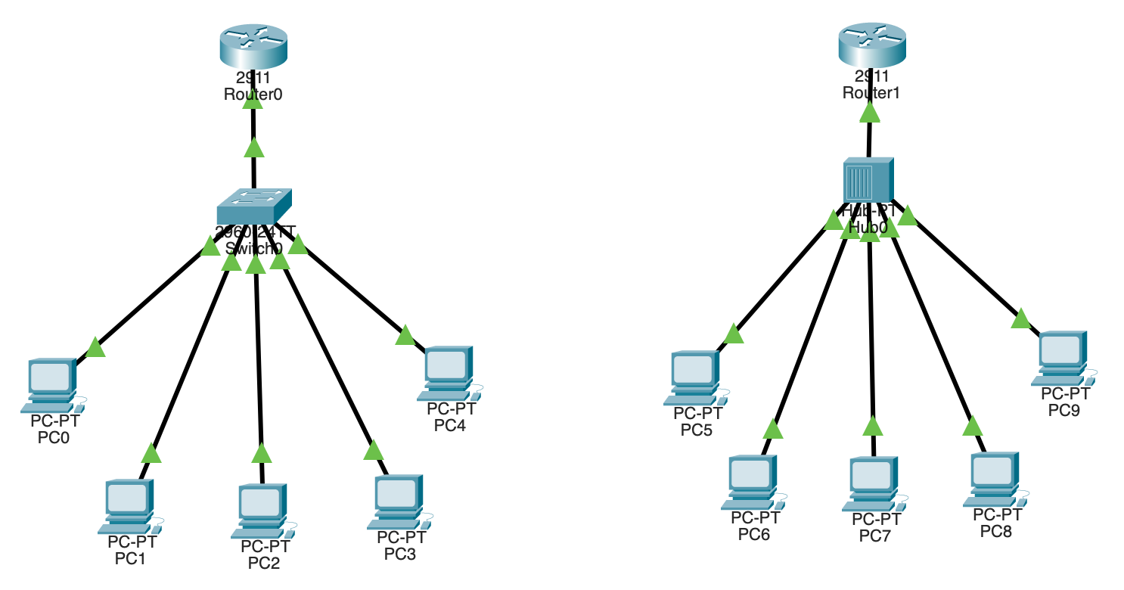

Interconnect the routers and configure the routing table:

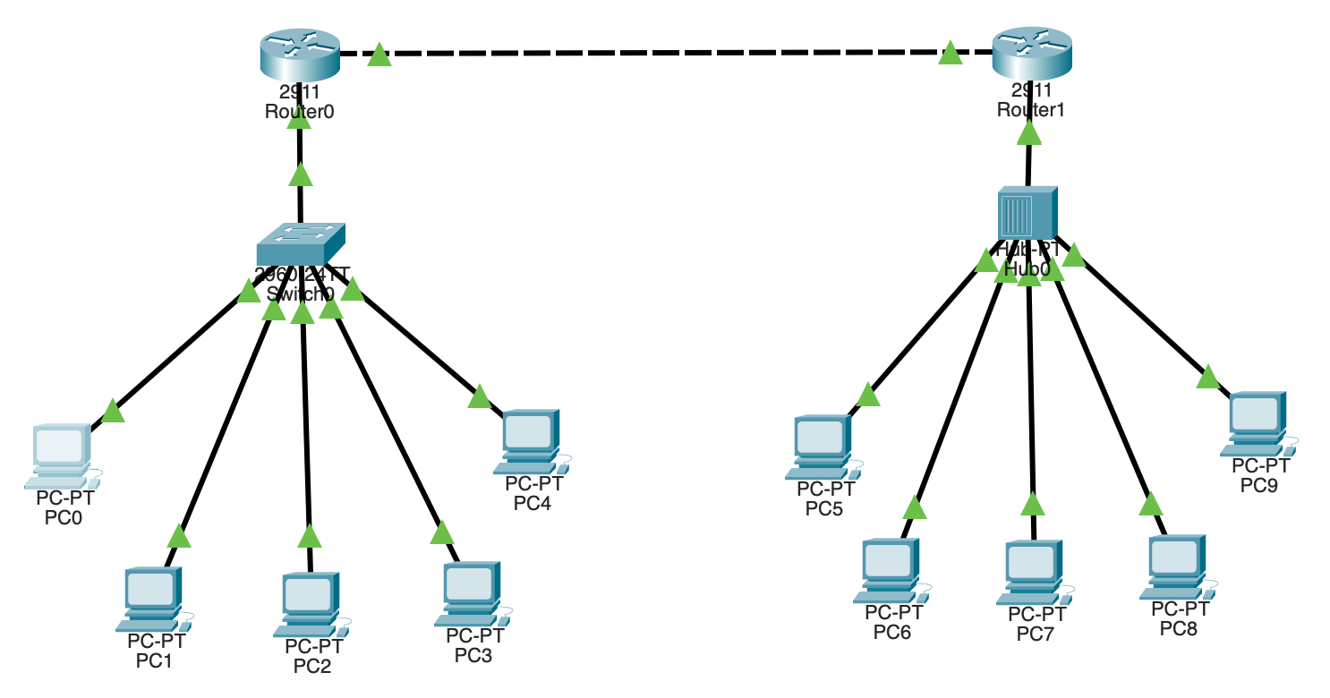

Understand the packet transmission across the LAN:

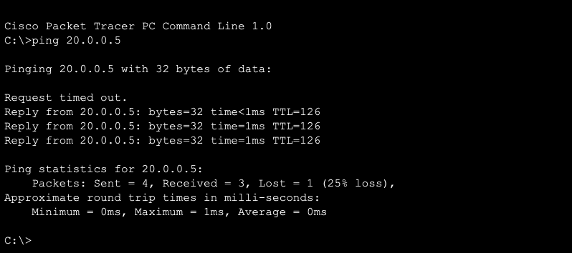

Security Analysis:

|  |  |  |
| --- | --- | --- |
| Vulnerabilities | Threats | Attack |
| Outdated software | Physical access with insider access | Malware infection to hardware by insider access |
| Weak passwords | Unauthorised access by gaining a password | Denial of service by blocking hub access |
| Lack of encryption | Data theft by insider attacks | Phishing by insider attack |
| Direct offline hub access |  |  |

Prevention:

* Keeping the nodes and hub in a sperate room for nobody to access directly.
* Encrypt and mandate strong password usage

Result:

This network is extremely secure, but all the nodes can only connect to each other and none of them to the internet. This type of connection is very good for local file storages and broadcasting. This also enables different LANs to connect with each other through the usage of multiple routers.